📝 Notes
Apr 29, 2026

[Check-in] Conserva Irrigation - V4 Company
Invited karina.reginato@conservairrigation.com Marcos Luciano Peretto - V4 Company (Peretto) Fhelipe Aranha Andrade Lucas Procópio
Attachments [Check-in] Conserva Irrigation - V4 Company
Meeting records Transcript Recording

Summary
Meeting strategy covered Google Ads optimization for cross-platform traffic and enterprise-level service management goals.
Google Ads Traffic Strategy
Ad campaigns utilize machine learning for mobile and website traffic optimization. Smart controllers manage site performance effectively.
B2B and B2C Operations
Service management integrates B2B and B2C models via local search and keyword targeting. Current open systems remain under review for service complaints.
Enterprise and Cloud Goals
Strategic focus shifts toward enterprise objectives and retail partnerships. Artificial intelligence integration remains a priority for cloud infrastructure.

Rate this Summary: Helpful or Not Helpful

Details
Did the screenshots in this section make your notes better or worse?
- Google Ads Strategy for Mobile and Website Traffic: Marcos Luciano discussed the strategy for Google Ads, noting that it covers mobile as well as website needs. The focus includes obtaining leaders for sacrifice and using the system for Google and blog control, referencing smart springer and controllers for website management (00:00:13).
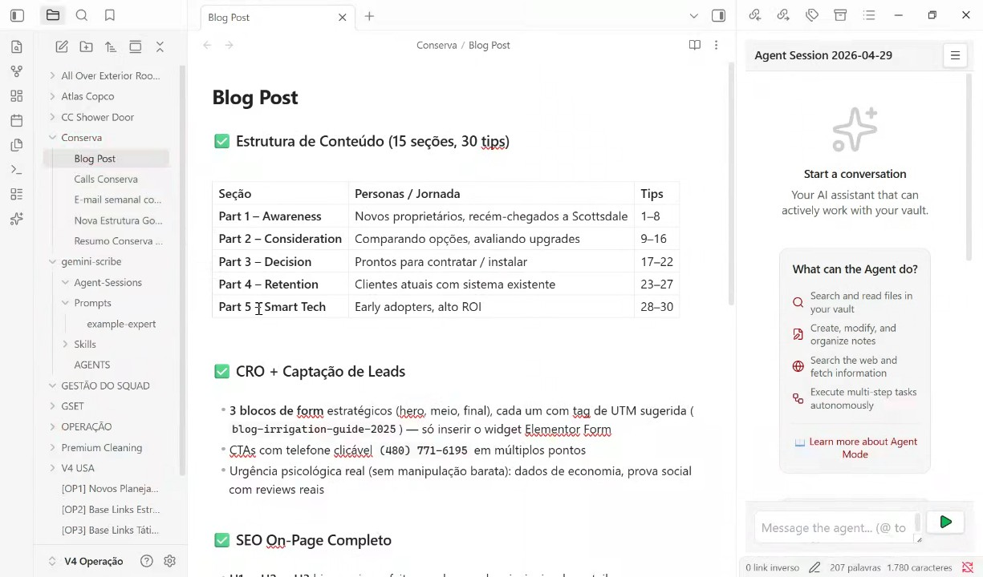
- B2B and B2C Considerations in Service and Traffic Management: The discussion addressed B2B and B2C considerations for service mind and traffic acquisition, mentioning both LSA Max Search and local services as relevant areas. The conversation noted the importance of keywords and machine learning, particularly for the B2B low season, and referenced issues like system installation and "Open models" that receive many complaints (00:16:15).
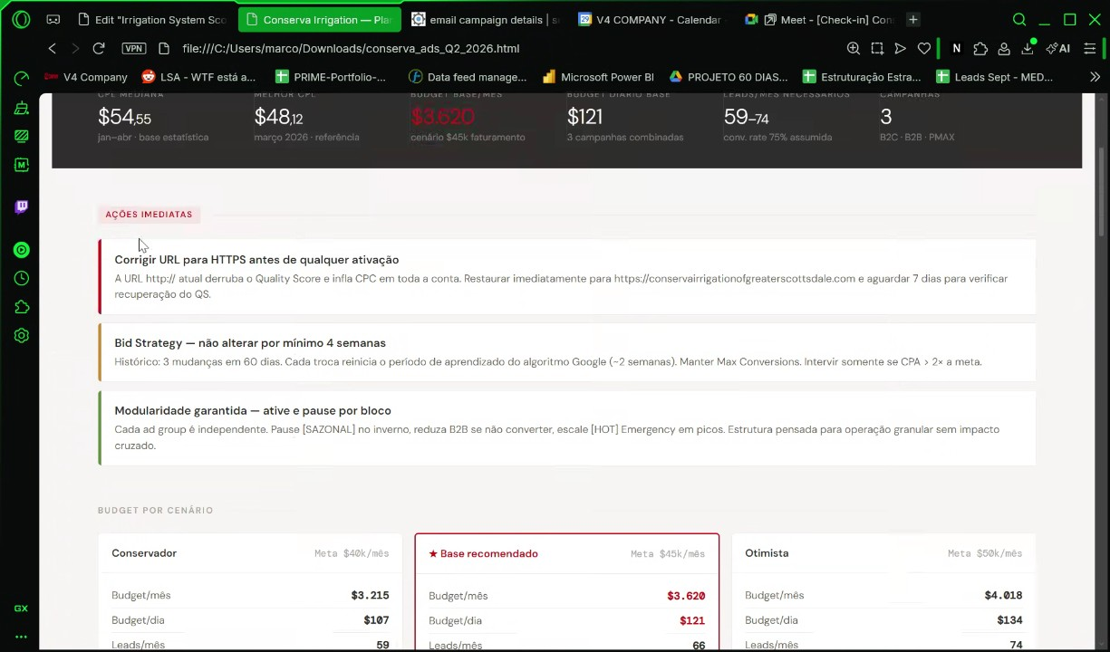
- Cloud Services and Artificial Intelligence: Marcos Luciano and Karina Reginato briefly discussed cloud services and artificial intelligence, referencing "Familia cloud" and the concept of "artificial consequent". They mentioned using Google and discussing the topic with Alberto, while also referencing travel and a specific observation related to a smart hydropod and water management (00:32:18).
- Enterprise Focus and Retailer Mention: The final topic of conversation centered on enterprise goals, with Marcos Luciano stating "Enterprise enterprise," and a mention of Home Depot as a potential retailer. The conversation concluded with Marcos Luciano thanking Karina Reginato (00:32:18).

You should review Gemini's notes to make sure they're accurate. Get tips and learn how Gemini takes notes
How is the quality of these specific notes? Take a short survey to let us know your feedback, including how helpful the notes were for your needs.

📖 Transcript
Apr 29, 2026

[Check-in] Conserva Irrigation - V4 Company - Transcript

00:00:13

Marcos Luciano: They me know question. See, I got in there.
Karina Reginato: Oh,
Marcos Luciano: Good.
Karina Reginato: yeah.
Marcos Luciano: Lego. for Google Ads.
Karina Reginato: Uh-huh. No.
Marcos Luciano: Yeah. This is uh this is this is for sacrific. leaders. That's a This is bread. for etchore. mobile. Yeah. for example. for Google. Yeah. Okay. website. Some Fore controllers. I take care. See
Karina Reginato: mute timeline. No.
Marcos Luciano: Yes.
Karina Reginato: 12. Uhhuh.
Marcos Luciano: Yeah. Okay. Fore!
Karina Reginato: Okay,
Marcos Luciano: Foreign! Foreign!
Karina Reginato: purple.
Marcos Luciano: Fore
Karina Reginato: Mhm.
Marcos Luciano: Google We may spring. Smart springer.
Karina Reginato: Okay. Oh, okay.
Marcos Luciano: for blog. Google
Karina Reginato: Okay.
Marcos Luciano: Fore control. Imagine
Karina Reginato: Okay.

00:16:15

Marcos Luciano: Foreign speech. Foreign
Karina Reginato: Uh-huh.
Marcos Luciano: speech.
Karina Reginato: Mhm.
Marcos Luciano: What are you? Fore B2B B2C consider for service mind. Fore speech.
Karina Reginato: Okay.
Marcos Luciano: traffic. Austral Foreign speech. Foreign speech. Foreign speech. significance. Outliers. Yeah. Yeah. Emergency repair system installation smart spring start up. This is Open models. So much complaints.
Karina Reginato: LP2C search LSA.
Marcos Luciano: LSA. Max search
Karina Reginato: Okay.
Marcos Luciano: local.
Karina Reginato: Okay.
Marcos Luciano: Fore local service. local
Karina Reginato: Next
Marcos Luciano: service.
Karina Reginato: slide.
Marcos Luciano: Perfect. foreign. Okay. for B2C. B2B stress stress
Karina Reginato: What?
Marcos Luciano: group.
Karina Reginato: All right.
Marcos Luciano: Maxert Keywords. Okay. Group Uh, mutad. Excellent.
Karina Reginato: Machine learning. B2B low
Marcos Luciano: Visually
Karina Reginato: season.

00:32:18

Marcos Luciano: X2.
Karina Reginato: And we do it. when I see my Okay,
Marcos Luciano: Wait.
Karina Reginato: there'll be
Marcos Luciano: Wait,
Karina Reginato: Youber.
Marcos Luciano: see Okay.
Karina Reginato: I start also
Marcos Luciano: forest.
Karina Reginato: is
Marcos Luciano: Contest Fantastic.
Karina Reginato: Familia cloud.
Marcos Luciano: I love Carolina
Karina Reginato: Yes, I'm with
Marcos Luciano: Google.
Karina Reginato: you.
Marcos Luciano: He's was
Karina Reginato: Alberto
Marcos Luciano: there.
Karina Reginato: Foreigelligent
Marcos Luciano: See
Karina Reginato: artificial consequent. Right.
Marcos Luciano: convers. Foreigil
Karina Reginato: I lost See,
Marcos Luciano: Travel.
Karina Reginato: I have a
Marcos Luciano: Ask Google.
Karina Reginato: My
Marcos Luciano: Fore!
Karina Reginato: friend
Marcos Luciano: Foreign! Foreign!
Karina Reginato: is itch.
Marcos Luciano: for
Karina Reginato: observation.
Marcos Luciano: heat. is.
Karina Reginato: Hunter
Marcos Luciano: Uh-huh.
Karina Reginato: smart
Marcos Luciano: f***. f***.
Karina Reginato: hydropod.
Marcos Luciano: Watch
Karina Reginato: Okay. Water management.
Marcos Luciano: the cheating. for
Karina Reginato: Mhm. Home Depot.
Marcos Luciano: sting. Mhm.
Karina Reginato: Okay.
Marcos Luciano: Thank you.
Karina Reginato: Okay.
Marcos Luciano: for watch.
Karina Reginato: Grandes.
Marcos Luciano: Perfect. Enterprise enterprise. Mhm. Okay. Okay. Google.
Karina Reginato: Okay. Come on.
Marcos Luciano: Touch out.

Transcription ended after 00:45:22

This editable transcript was computer generated and might contain errors. People can also change the text after it was created.

